# System and Software Architecture Description (SSAD)

**LA Commons upgrade of website**

**Team 1**

|  |  |  |
| --- | --- | --- |
| **Name** | **Primary Role** | **Secondary Role** |
| Hualong Zu | Project Manager | Prototyper |
| Qihua Wu | Life Cycle Planner | Oper-Concept Engineer |
| Taizhi Li | Requirements Engineer | Life Cycle Planner |
| Huaiqi Wang | Prototyper | Requirements Engineer |
| Tianyi Luo | Feasibility Analyst | System Architect |
| Yueheng Li | System Architect | Oper-Concept Engineer |
| Steiniger, Herman, L | IIV & V | Quality Focal Point |

**11/27/2013**

# Version History

| Date | Author | Version | Changes made | Rationale |
| --- | --- | --- | --- | --- |
| 10/19/13 | Yueheng Li | 1.0 | * Original SSAD template * Constructed system context diagrams, use-case diagrams, deployment diagrams, behavior diagrams * Embedded description in each Tab | * Initial version of the SSAD, ver 1.0 * To fulfill the exit conditions of Draft FC package |
| 11/21/13 | Yueheng Li | 2.0 | * Changed the Use-case diagrams according the requirement changing * Changed the system context diagrams | * To meet on response to Evaluation of Core FC Package |
| 11/27/13 | Taizhi Li, Yueheng Li | 3.0 | * Add the section 1, 2 and 3 * Constructed the Artifact and Information diagram * Modified all of the diagrams according the lecture of “SSAD IN DC” | * To be consistent with ICM EPG SSAD template * To identify the document for NDI and NCS Project |

# Table of Contents

System and Software Architecture Description (SSAD) i

Version History ii

Table of Contents iii

Table of Tables iv

Table of Figures v

1. Introduction 1

1.1 Purpose of the SSAD 1

1.2 Status of the SSAD 1

2. System Analysis 2

2.1 System Analysis Overview 2

3. NDI/NCS Interoperability Analysis 5

3.1 Introduction 5

3.2 System Structure 5

3.3 Evaluation Summary 5

# Table of Tables

Table 1: Actors Summary 2

Table 2: Artifacts and Information Summary 3

Table 3: Process Description 4

Table 4: Typical Course of Action 4

Table 5: Alternate Course of Action 4

Table 6: Exceptional Course of Action 4

Table 7: NDI Products Listing 5

Table 8: NDI Evaluation 6

# Table of Figures

Figure 1: System Context Diagram 2

Figure 2: Artifacts and Information Diagram 3

Figure 3: Process Diagram 4

### Introduction

#### Purpose of the SSAD

The purpose of the SSAD is to record the results of the object-oriented analysis and upgrade the LA Commons website. This document is critical in transition from foundation phase to development phase by providing architectural design of the proposed system. Later, the programmers and developers of our team can use this SSAD as reference to the architecture of the system that we are developing. During the development of this system, our team will be faithful to the structure of the system described in SSAD.

#### Status of the SSAD

This SSAD is the version 3.0. This version we correct some mistakes mentioned by TA, and add the content in section 1, 2 and 3.

This SSAD is the version 3.4. This version we correct some mistakes mentioned by TA.

### System Analysis

#### System Analysis Overview

The primary purpose of LA Commons Website, which is developing now, is to market and promote LA Commons events, and to showcase arts work properly on the website. On the other hand, the website will help to increased the visibility of art projects of LA Commons, to increase acknowledgement of neighborhood’s arts and culture. Through displaying galleries, more funds will be raised, and popularity and reputation of LA Commons events should be increased.

##### System Context

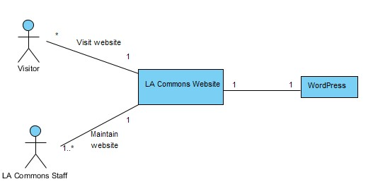

Figure 1: System Context Diagram

Table 1: Actors Summary

| **Actor** | **Description** | **Responsibilities** |
| --- | --- | --- |
| Visitor | Visitor is a user who views the contents of the website and finds information about the neighborhoods and projects. The visitor can be a funder, youth artist, artist, community member, tourist | View gallery images on Project Page and Gallery Page  View the Project/Neighborhoods Pages  View the Trekking LA  Visit interactive map  Share events to Facebook |
| LA_Commons_Staff | An executive/managerial staff of this website. | Post new projects  Add new events to interactive map  Share projects to Facebook  Add pictures to Gallery of art works |

##### Artifacts & Information

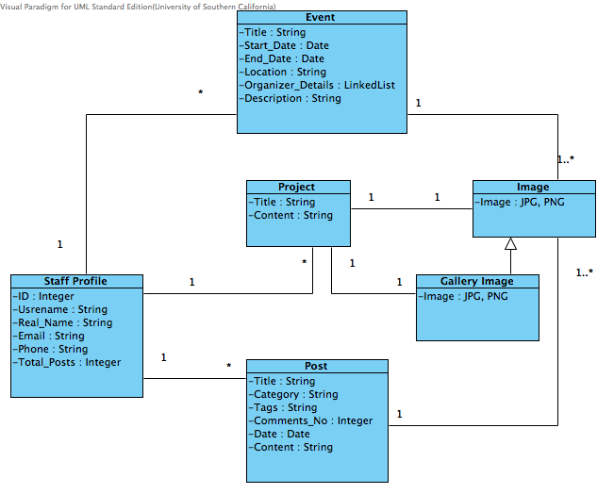Figure 2: Artifacts and Information Diagram

Table 2: Artifacts and Information Summary

|  |  |
| --- | --- |
| **Artifact** | **Purpose** |
| Image | To show all the images uploaded by the website administrators. The formats of images are JPG and PNG. |
| Gallery Image | To show all the images displayed in galleries of Project Pages and Gallery Page. |
| Post | To store all the blogs edited by the LA Commons staffs, including blogs’ titles, categories, tags, total comments number, published date and blog contents. |
| Project | To give a brief description of neighborhoods’ projects, including the projects’ titles and text descriptions. |
| Event | To give the detailed information of the upcoming events held by LA Commons, including the events’ titles, start-dates, end- dates, locations, organizers’ details and descriptions. |
| Staff Profile | To store the information of LA Commons staffs, including the staff ID, username, real name, email address, phone number and total posts number. |

##### Behavior

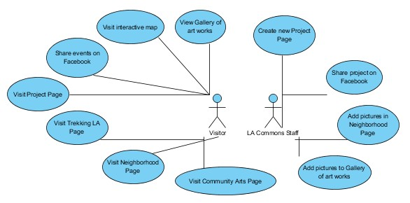

<<Use-Case Diagram>>

Figure 3: Process Diagram

###### Interactive Map

Visit interactive map

|  |  |
| --- | --- |
| Main | |
| **Identifier** | UC02 - Visit interactive map |
| **Purpose** | By checking the interactive map, visitor could have a brief introduction about recent tours and community arts |
| **Requirements** | WC_2700 : As a visitor, I can see by the interactive map how many different neighbourhoods in Los Angeles area LA Commons has partnered with and created programs for, and upcoming tours and community arts of the neighbourhoods in the interactive map. |
| **Development Risks** | High |
| **Pre-conditions** | Visitor is visiting the homepage of LA Commons |
| **Post-conditions** | The page of Interactive Map is shown or Error page is displayed |
| **Flow of Events** | |  |  |  | | --- | --- | --- | |  | Actor Input | System Response | | 1 | Click Neighbourhoods on homepage |  | | 2 |  | Display a dropdown list which contain the whole list of neighbourhoods | | 3 | Choose map |  | | 4 |  | Display a interactive map | | 5 | Hover mouse over a neighbourhood point |  | | 6 |  | Show a box containing Community Arts Program and Tours | | 7 | Click the link in the box |  | | 8 |  | Check the validation of the link and display corresponding page | |
| **Exception** | |  |  |  | | --- | --- | --- | |  | Actor Input | System Response | | 1 | Click Neighbourhoods on homepage |  | | 2 |  | Display a dropdown list which contain the whole list of neighbourhoods | | 3 | Choose map |  | | 4 |  | Display a interactive map | | 5 | Hover mouse over a neighbourhood point |  | | 6 |  | Show a box containing Community Arts Program and Tours | | 7 | Click the link in the box |  | | 8 |  | Check the validation of the link, find the link is invalid and display 404 or 500 error page | |

###### 

###### Community Arts project page

Visit project page

|  |  |
| --- | --- |
| Main | |
| **Identifier** | UC04 - Visit project page |
| **Purpose** | By visiting project pages, knows more about previous and current projects |
| **Requirements** | WC_2561 : As a visitor, I can see the Community Arts Programming related documents on the website so that I know more about this program. Funders can see where their money going. Youth artists can use their art works in resume for college. Artists can use these projects as in their resume. Community members can see what's going on in their neighbourhoods. Tourists can see what's going on in LA.  WC_2817: As a visitor, I can access specific neighbourhood community arts program information from both the "Programs" tab (dropdown - Community Arts) and the "Neighbourhood" tab (dropdown - specific neighbourhoods) |
| **Development Risks** | Medium |
| **Pre-conditions** | Visitor is visiting the Neighbourhood Page of LA Commons |
| **Post-conditions** | The page of a project is shown or Error page is displayed |
| **Flow of Events** | |  |  |  | | --- | --- | --- | |  | Actor Input | System Response | | 1 | Click the right bottom of the page |  | | 2 |  | Read image and gallery from plugin, display the corresponding project page, which has a image and a gallery and description of the project. | | 3 | Click thumbnail of the gallery |  | | 4 |  | Display the corresponding image of the thumbnail | | 5 | Click left or right arrow of the gallery |  | | 6 |  | Display previous or next image | |
| **Exception** | |  |  |  | | --- | --- | --- | |  | Actor Input | System Response | | 1 | Click the right bottom of the page |  | | 2 |  | Read image and gallery from plugin, fail in reading, display 404 or 500 error page | |

Visit Community Arts Page

|  |  |
| --- | --- |
| Main | |
| **Identifier** | UC07 - Visit Community Arts Page |
| **Purpose** | Visitor could access community arts program from the Community Arts page |
| **Requirements** | WC_2817: As a visitor, I can access specific neighbourhood community arts program information from both the "Programs" tab (dropdown - Community Arts) and the "Neighbourhood" tab (dropdown - specific neighbourhoods) |
| **Development Risks** | Low |
| **Pre-conditions** | Visitor is visiting the homepage of LA Commons |
| **Post-conditions** | The page of a project is shown or Error page is displayed |
| **Flow of Events** | |  |  |  | | --- | --- | --- | |  | Actor Input | System Response | | 1 | Click Programs on homepage |  | | 2 |  | Display a dropdown list | | 3 | Click Community Arts from the dropdown list |  | | 4 |  | Display the Commonity Arts page, which contains links to project pages | | 5 | Click the link |  | | 6 |  | Check the validation of the link, display the corresponding project page | |
| **Exception** | |  |  |  | | --- | --- | --- | |  | Actor Input | System Response | | 1 | Click Programs on homepage |  | | 2 |  | Display a dropdown list | | 3 | Click Community Arts from the dropdown list |  | | 4 |  | Display the Community Arts page, which contains links to project pages | | 5 | Click the link |  | | 6 |  | Check the validation of the link, find link is invalid, display 404 or 500 error page | |

Create new project Page

|  |  |
| --- | --- |
| Main | |
| **Identifier** | UC08 - Create new project Page |
| **Purpose** | Add information about Youth Artist or Neighbourhood Project |
| **Requirements** | WC_2558 : As a worker at LA Commons, I can maintain the website of LA Commons so that it will let the users visit the website more safely and stably  WC_2562 : As LA Commons staff, I can use the template to enter and save the past ten-year project documents after accepting Wordpress training provided by developers |
| **Development Risks** | Medium |
| **Pre-conditions** | LA Commons staff has logined to Wordpress; the gallery file has been created |
| **Post-conditions** | Create a new page about the project with a gallery or not |
| **Flow of Events** | |  |  |  | | --- | --- | --- | |  | Actor Input | System Response | | 1 | Click Page, Add new from the left side of the dashboard |  | | 2 |  | Display a new section on the right side of the dashboard | | 3 | Add image, gallery and description of the project, and Click Publish |  | | 4 |  | Read gallery from plugin, create new project page which has gallery on LA Commons website | |
| **Exception** | |  |  |  | | --- | --- | --- | |  | Actor Input | System Response | | 1 | Click Page, Add new from the left side of the dashboard |  | | 2 |  | Display a new section on the right side of the dashboard | | 3 | Add image, gallery and description of the project, and Click Publish |  | | 4 |  | Read gallery from plugin, fali in reading, create new project page which has no gallery on LA Commons website | |

Visit Trekking LA Page

|  |  |
| --- | --- |
| Main | |
| **Identifier** | UC05 - Visit Trekking LA Page |
| **Purpose** | Visitor could visit Trekking LA on LA Commons website which has a better layout |
| **Requirements** | WC_2699 : As a visitor, I can see a better layout of LA Commons website ao that I can be more attracted by programs and spend more time on the website.(For example, condense the "upcoming tour" section in "trekking LA" page) |
| **Development Risks** | Low |
| **Pre-conditions** | Visitor is visiting the homepage of LA Commons |
| **Post-conditions** | The page of Trekking LA is shown or Error page is displayed |
| **Flow of Events** | |  |  |  | | --- | --- | --- | |  | Actor Input | System Response | | 1 | Click Programs on homepage |  | | 2 |  | Display a dropdown list | | 3 | Click Trekking LA from the dropdown list |  | | 4 |  | Read images and texts, display the Trekking LA page, which contains a description of upcoming tours that has a better layout | |
| **Exception** | |  |  |  | | --- | --- | --- | |  | Actor Input | System Response | | 1 | Click Programs on homepage |  | | 2 |  | Display a dropdown list | | 3 | Click Trekking LA from the dropdown list |  | | 4 |  | Read images and texts, fail in reading, display 404 or 500 error page | |

###### Neighborhood Page Upgrade

Visit Neighborhood Page

|  |  |
| --- | --- |
| Main | |
| **Identifier** | UC06 - Visit Neighbourhood Page |
| **Purpose** | Visitor will know more about what's happening between neighbourhood |
| **Requirements** | WC_2557 : As a visitor, I can view a gallery of art works of community arts program  WC_2697 : As a visitor, I can clearly identify the various Community Arts Programming on the "Neighbourhood" web page, along with the most current applicable Tour information |
| **Development Risks** | Medium |
| **Pre-conditions** | Visitor is visiting the homepage of LA Commons |
| **Post-conditions** | The page of neighbourhood is shown or Error page is displayed |
| **Flow of Events** | |  |  |  | | --- | --- | --- | |  | Actor Input | System Response | | 1 | Click Neighbourhoods on homepage |  | | 2 |  | Display a dropdown list which contain the whole list of neighbourhoods | | 3 | Click on a particular neighbourhood |  | | 4 |  | Read gallery from plugin, display the corresponding neighbourhood page, which has a small gallery of Community Art Program on the right bottom of the page. | |
| **Exception** | |  |  |  | | --- | --- | --- | |  | Actor Input | System Response | | 1 | Click Neighbourhoods on homepage |  | | 2 |  | Display a dropdown list which contain the whole list of neighbourhoods | | 3 | Click on a particular neighbourhood |  | | 4 |  | Read gallery from plugin, fail in reading, display 404 or 500 error page | |

Add pictures in Neighbourhood Page

|  |  |
| --- | --- |
| Main | |
| **Identifier** | UC10 - Add pictures in Neighbourhood Page |
| **Purpose** | Post pictures in Neighbourhood Page |
| **Requirements** | WC_2558 : As a worker at LA Commons, I can maintain the website of LA Commons so that it will let the users visit the website more safely and stably |
| **Development Risks** | Medium |
| **Pre-conditions** | LA Commons staff has logged in to Wordpress |
| **Post-conditions** | Post pictures to gallery in the Neighbourhood or not |
| **Flow of Events** | |  |  |  | | --- | --- | --- | |  | Actor Input | System Response | | 1 | Click Post, NewPost from the left of the dashboard |  | | 2 |  | Display a new section on the right side of the dashboard | | 3 | Click Add File. Choose pictures from computer. Click Upload. Choose categories from neighborhood. Click Publish |  | | 4 |  | Read pictures, add new pictures to gallery in the Neighborhood section | |
| **Exception** | |  |  |  | | --- | --- | --- | |  | Actor Input | System Response | | 1 | Click Post, NewPost from the left of the dashboard |  | | 2 |  | Display a new section on the right side of the dashboard | | 3 | Click Add File. Choose pictures from computer. Click Upload. Choose categories from neighborhood. Click Publish |  | | 4 |  | Read pictures, fail in reading, can not add new pictures to gallery in the Neighborhood section | |

###### Social Network Share Function

Share events on Facebook

|  |  |
| --- | --- |
| Main | |
| **Identifier** | UC03 - Share events on Facebook |
| **Purpose** | If visitor likes a specific event, he/she could post project information to Facebook |
| **Requirements** | WC_2563 : As a visitor, I can share my favourite events to the social media so that I can invite more friends to attend the upcoming events and enlarge the social influence of the projects |
| **Development Risks** | Low |
| **Pre-conditions** | Visitor has a Facebook account; Visitor is visiting the event page of LA Commons |
| **Post-conditions** | Visitor shares events on Facebook or error message is displayed |
| **Flow of Events** | |  |  |  | | --- | --- | --- | |  | Actor Input | System Response | | 1 | Click Facebook button on website pages |  | | 2 |  | Display a new window for logging in to Facebook | | 3 | Enter user name and password of Facebook and click Log in |  | | 4 |  | Send user name and password to Facebook database and check name and password | | 5 | Write post on user facebook wall |  | | 6 |  | Post posts about the project on user's Facebook timeline | |
| **Alternate** | |  |  |  | | --- | --- | --- | |  | Actor Input | System Response | | 1 | Click Facebook button on website pages |  | | 2 |  | Checked visitor has logged in Facebook, display a new window for writing Facebook post | | 3 | Write post on visitor's facebook wall |  | | 4 |  | Post posts about the project on visitor's Facebook timeline | |
| **Exception** | |  |  |  | | --- | --- | --- | |  | Actor Input | System Response | | 1 | Click Facebook button on website pages |  | | 2 |  | Display a new window for logging in to Facebook | | 3 | Enter user name and password of Facebook and click Log in |  | | 4 |  | Send user name and password to Facebook database, check name and password, find invalid name and password match, and show invalid user name or password | |

Share project on Facebook

|  |  |
| --- | --- |
| Main | |
| **Identifier** | UC09 - Share project on Facebook |
| **Purpose** | If LA Commons Staff likes a specific project, he/she could post project information to Facebook |
| **Requirements** | WC_2556 : As a worker at LA Commons, I can share our project documents to social media so that it will increase our influence on Internet |
| **Development Risks** | Low |
| **Pre-conditions** | LA Commons Staff has a Facebook account and is visiting project page |
| **Post-conditions** | Share project on Facebook or error message is displayed |
| **Flow of Events** | |  |  |  | | --- | --- | --- | |  | Actor Input | System Response | | 1 | Click Facebook button on website pages |  | | 2 |  | Display a new window for logging in to Facebook | | 3 | Enter user name and password of Facebook and click Log in |  | | 4 |  | Send user name and password to Facebook database and check name and password | | 5 | Write post on user Facebook wall |  | | 6 |  | Post posts about the project on LA Commons Staff's Facebook timeline | |
| **Alternate** | |  |  |  | | --- | --- | --- | |  | Actor Input | System Response | | 1 | Click Facebook button on website pages |  | | 2 |  | Checked LA Commons staff has logged in Facebook, display a new window for writing Facebook post | | 3 | Write post on LA Commons staff facebook wall |  | | 4 |  | Post posts about the project on LA Commons staff's Facebook timeline | |
| **Exception** | |  |  |  | | --- | --- | --- | |  | Actor Input | System Response | | 1 | Click Facebook button on website pages |  | | 2 |  | Display new window to login in to Facebook | | 3 | Enter user name and password of Facebook and click Log in |  | | 4 |  | Send user name and password to Facebook database, check name and password, find invalid name and password match, and show invalid user name or password | |

###### Gallery of art works

View Gallery of art works

|  |  |
| --- | --- |
| Main | |
| **Identifier** | UC01 - View Gallery of art works |
| **Purpose** | Visitor could visit the gallery of artwork, hence knows more about LA. |
| **Requirements** | WC_2557 : As a visitor, I can view a gallery of art works of youth arts program. |
| **Development Risks** | Low |
| **Pre-conditions** | Visitor is visiting the homepage of LA Commons |
| **Post-conditions** | The page of Gallery of Artwork is shown or Error page is displayed |
| **Flow of Events** | |  |  |  | | --- | --- | --- | |  | Actor Input | System Response | | 1 | Click Gallery on homepage |  | | 2 |  | Read gallery from plugin, display a new page of Gallery of Artwork | | 3 | Click left or right arrow of the gallery |  | | 4 |  | Display previous or next image | | 5 | Click image of the Gallery |  | | 6 |  | Check the validation of the link of the image, display corresponding Project page | |
| **Exception** | |  |  |  | | --- | --- | --- | |  | Actor Input | System Response | | 1 | Click Gallery on homepage |  | | 2 |  | Read gallery from plugin, fail in reading, display 404 or 500 error page | |
| **Exception** | |  |  |  | | --- | --- | --- | |  | Actor Input | System Response | | 1 | Click Gallery on homepage |  | | 2 |  | Read gallery from plugin, display a new page of Gallery of Artwork | | 3 | Click left or right arrow of the gallery |  | | 4 |  | Display previous or next image | | 5 | Click image of the Gallery |  | | 6 |  | Check the validation of the link of the image, find the link is invalid, display 404 or 500 error page | |

Add pictures to Gallery of art works

|  |  |
| --- | --- |
| Main | |
| **Super Use Case** | UC11 - Add pictures to Gallery of art works |
| **Purpose** | Add new pictures to Gallery |
| **Requirements** | WC_2558 : As a worker at LA Commons, I can maintain the website of LA Commons so that it will let the users visit the website more safely and stably. |
| **Development Risks** | Low |
| **Pre-conditions** | LA Commons staff has logged in to Wordpress |
| **Post-conditions** | Add new picture to Gallery or display Error page |
| **Flow of Events** | |  |  |  | | --- | --- | --- | |  | Actor Input | System Response | | 1 | Click Gallery, Add new from the left side of the dashboard |  | | 2 |  | Display a new section on the right side of the dashboard | | 3 | Add images and Click Publish |  | | 4 |  | Read images, add new pictures to Gallery | |
| **Exception** | |  |  |  | | --- | --- | --- | |  | Actor Input | System Response | | 1 | Click Gallery, Add new from the left side of the dashboard |  | | 2 |  | Display a new section on the right side of the dashboard | | 3 | Add images and Click Publish |  | | 4 |  | Read images, fail in reading, can not add new pictures to Gallery | |

### NDI/NCS Interoperability Analysis

#### Introduction

Since our project’s main responsibility is to upgrade “LA Commons” current website, we need to add features and modify the current website’s flow of information using the WordPress and it’s plugins. Currently, the whole LA Commons’ website is built on WordPress, and there are some useful plugins we can directly use and optimize.

##### COTS / GOTS / ROTS / Open Source / NCS

Table 7: NDI Products Listing

|  |  |
| --- | --- |
| **NDI/NCS Products** | **Purposes** |
| WordPress | This offers the general solution for the website. And this is what client currently uses. |
| BlueHost | This provides the hosting solution for the website. And this is what the client currently uses. |
| WOW Slider  NextGen Gallery | An image gallery that will display a set of thumbnails and the corresponding large image attached to the right portion of a project’s post or page. An image gallery should also provide a slide show function in Gallery page. This way, we can achieve WC_2561 & WC_2557 |
| MapPress Easy Google Maps  Leaflet Maps Marker | It will help the client to create an interactive map to show the neighborhoods in the Los Angeles area that “LA Commons” has partnered with or created programs for. This way, we can achieve WC_2700 |
| Add This  Share This | It will enable page past to be shared by visitors. This will increase the engagement from visitors and increase the website’s traffic. And this way we can achieve the WC_2563 and WC_2556 |

##### Connectors

- In this project, wordpress manages the connection with MySQL database automatically. Type: data access connector.

- In this project, “WordPress Gallery Widget” or “NextGen Gallery” manages the connection with data storage and MySQL automatically. Type: data access connectors and linkage connectors.

- In this project, “MapPress Easy Google Maps” or “Leaflet Maps Marker” uses absolute hypertext link or image’s absolute URL link to connect with detailed neighborhood page. Type: linkage connectors.

- In this project, “Add This” or “Share This” uses Facebook API, Twitter API, LinkedIn API, etc. to connect the blog post with social media. Type: remote procedural calls and linkage connectors.

##### Legacy System

- In this project, the current website is still be used. And WordPress used to edit the webpage, maintain the website is still used to upgrade the LA Commons website. Bluehost is still used in the development of the website.

- In this project, the “WordPress Gallery Widget” has to be able to interoperate well with “WordPress” version 3.6.1, which is the website solution that the client is currently using.

- In this project, the “Leaflet Maps Marker” has to be able to work well with “WordPress” version 3.6.1.

- In this project, the “Add This” has to be able to work well with “WordPress” version 3.6.1.

- In this project, the “NextGen Gallery” has to be able to work well with “WrodPress” version 3.6.1.

#### System Structure

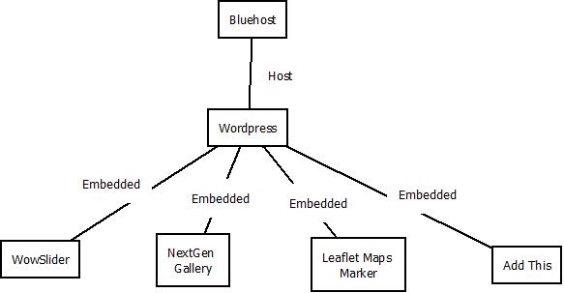

Figure4: System Structure

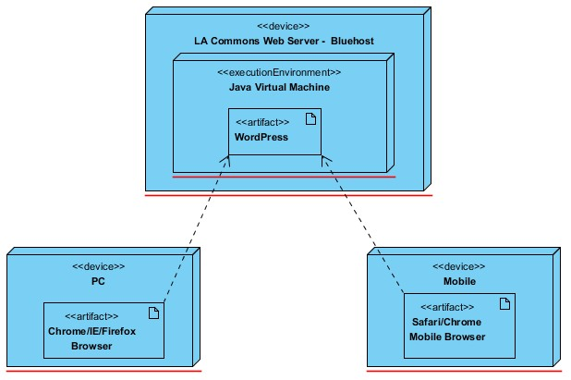

Figure5: Deployment Diagram

#### Evaluation Summary

Four persons in our team evaluated the NDIs. After calculation, we found that “WOW Slider” is better to achieve the feature that “Community Arts Project page will have a gallery to show the various arts projects pictures” - WC_2561. “Leaflet Maps Marker” should be used to achieve “interactive map feature” - WC_2700. “Add This” should be used to achieve “sharing functions” including project page sharing and featured event sharing - WC_2563 & WC_2556.

Note that: “NextGen Gallery” should also be used in our implementation even though WOW Slider has a higher score in comparison, because “WOW Slider” cannot perform the function that “Visitor can view a gallery of Community Arts Programming” – WC_2557.

The following table shows the usages of the above selected NDI item, and gave the comments for each feasible NDI item.

Table 10: NDI Evaluation

|  |  |  |
| --- | --- | --- |
| **NDI** | **Usages** | **Comments** |
| WordPress | Upgrade and maintain the website.  WC_2697 WC_2699 WC_2562 | **Positive Points:**  -Currently used  -Widely used  -Information all over the internet  -Client is familiar with  **Note:** There is no comparison between other component with this one |
| BlueHost | Host the website whole solutions and database | **Positive Points:**  -Currently used  -Widely used in the current world  -Information all over the internet  -Client is familiar with  **Negative Points:**  -Not free  **Note:** There is no comparison between other component with this one |
| WOW Slider | Display the gallery of arts projects pictures under the Community Arts Project page  WC_2561 | **Positive Points:**  -Reliable vender support  -Strong customization tools  -Multiple layout and templates options  -Fancy displaying effects  **Negative Points:**  -Free version has watermark  -Relative hard to use for client |
| NextGen Gallery | Display a slideshow under “Gallery” tab  WC_2557 | **Positive Points:**  -7.5 million downloads  -Update frequently  -Currently installed in WordPress with Pro version |
| Leaflet Maps Marker | Interactive map with neighborhoods  WC_2700 | **Positive Points:**  -Easy way to add point in the map  -Allow to customize pop-up window  **Negative Points**:  -Advanced features needs payment  -Unknown compatibility with WordPress 3.6.1 |
| Add This | Enable sharing features in blog posts  WC_2563 WC_2556 | **Positive Points:**  -Over 330 social services  -Widely used  -Update frequently  **Negative Points**:  -No custom button  -Limited customizable options |